

**ORACLE VM SERVER ADMINISTRATION**

**LAB FILE**

**SUBMITTED BY: SUBMITTED TO:**

AYUSH KUMAR JHA RAVI SINGHAL SIR

500086400

B.C.A (IOT)

(2020-2023)

**EXPERIMENT-1**

**To understand the physical machine and its available resources for creating new virtual machines. Student should analyse and note down the hardware resources of the physical machine. Now note down the resources that can be used for creating new VM machines. Hardware resources to be noted are as below:**

1. **Processor (total number of available cores)**
2. **Memory i.e., Total RAM installed in a physical machine**
3. **Secondary storage i.e., total Hard disk installed in a physical machine.**

|  |  |  |  |  |
| --- | --- | --- | --- | --- |
| **S.NO** | **RESOURCE** | **TOTAL** | **UTILIZED** | **AVAILABLE** |
| **1** | Processor | **4 Cores and 8 LPU** | **1 Core and 2 LPU** | **3 Core and 6 LPU** |
| **2** | Memory | **7.8 GB** | **4.9 GB** | **2.9 GB** |
| **3** | Secondary Memory | **477 GB** | **180.2 GB** | **296.8 GB** |

**EXPERIMENT-2**

**As per the available resources identified in Experiment no.1 create new virtual machines.**

1. **Install Oracle Virtual Box in a Lab Workstation**
2. **Create a new virtual machine with available resources (Memory minimum 2048 MB).**
3. **Select OS iso from your d/e drive**
4. **Install the OS**
5. **Create your own Users in OS**

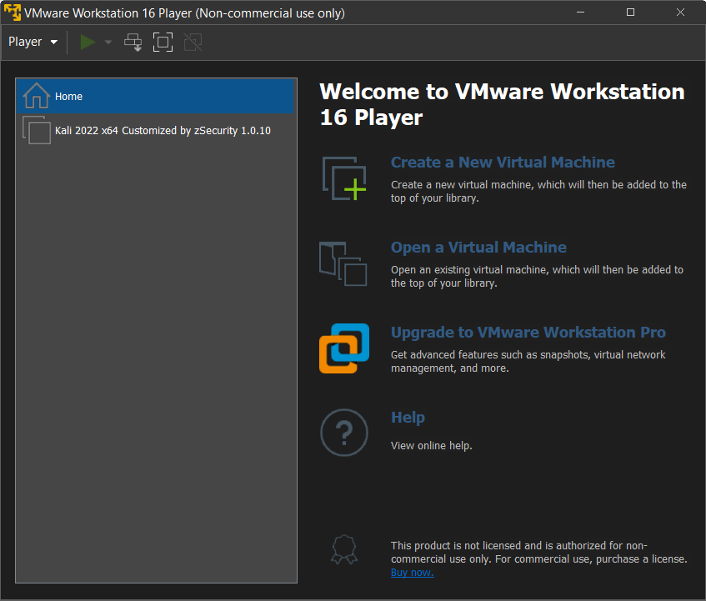

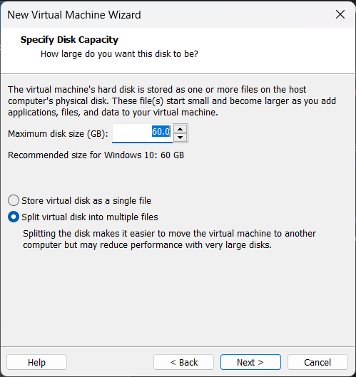

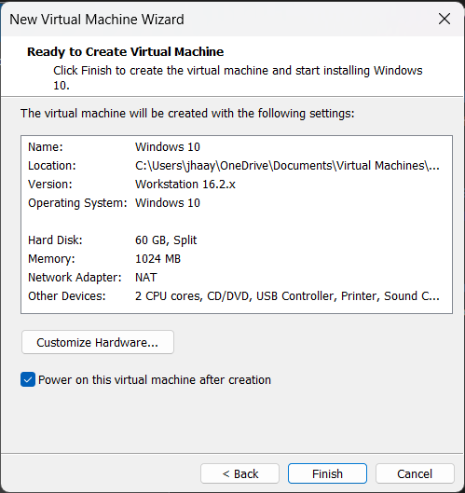

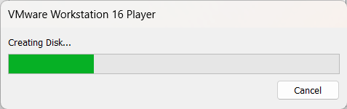

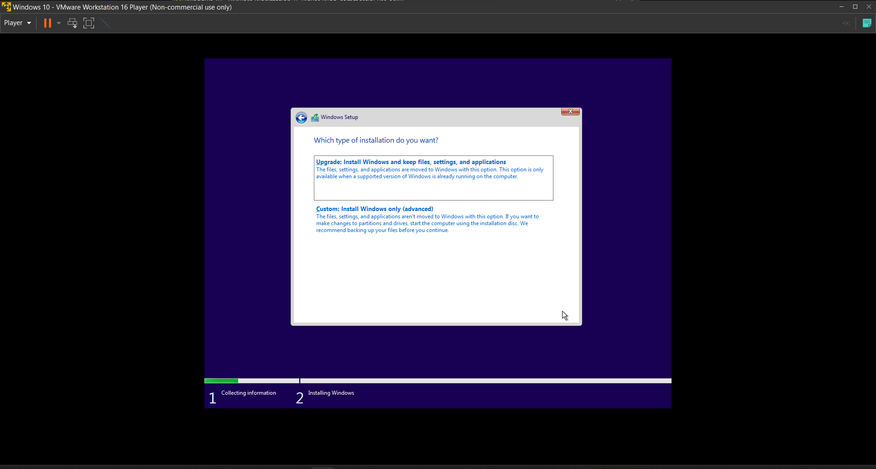

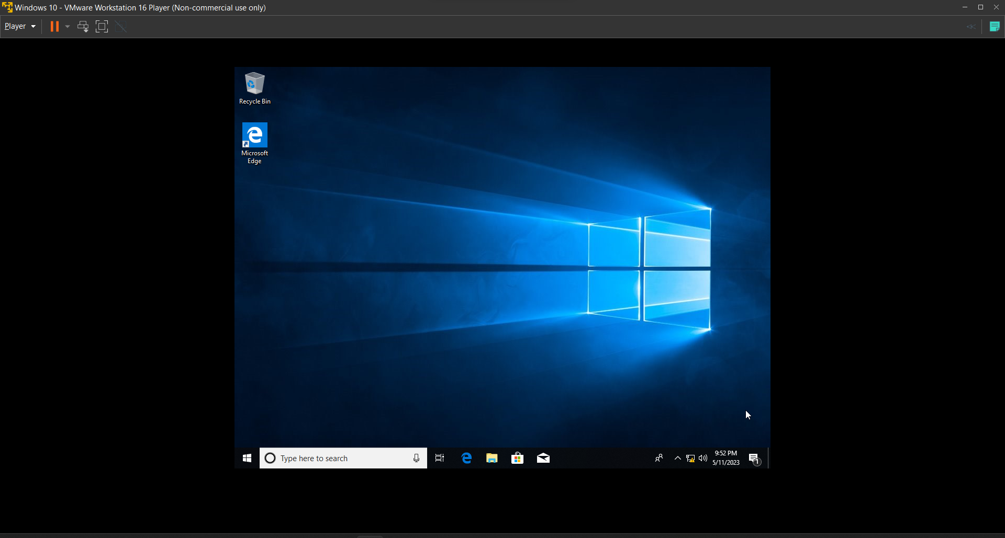

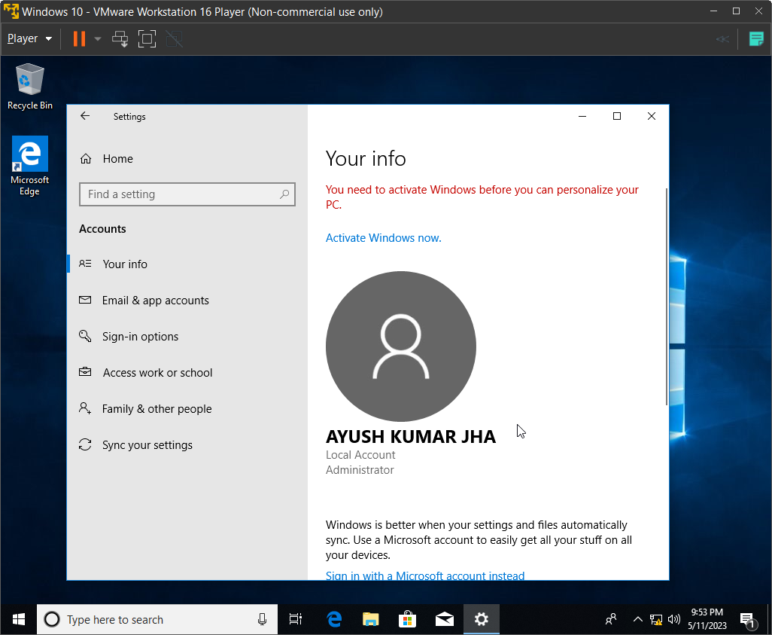

**EXPERIMENT – 3**

**Configuring Virtual Network**

**Students must check the network adapters of their Virtual Machine and perform the following task**

1. **Identify the type of network it is connected (Ethernet or WiFi)**
2. **Check the IP details of the VM. (Whether static of dynamic)**
3. **Note down the IP configuration of the VM with DNS and gateway**
4. **If IP is found assigned by DHCP then assign the static IPs as follows:**

**172.16.1.102**

**255.255.0.0**

**172.16.1.101**

**172.16.1.101**

**Assign IP address 172.16.1.101 to the Virtual Server Machine that has been created using Server OS.**

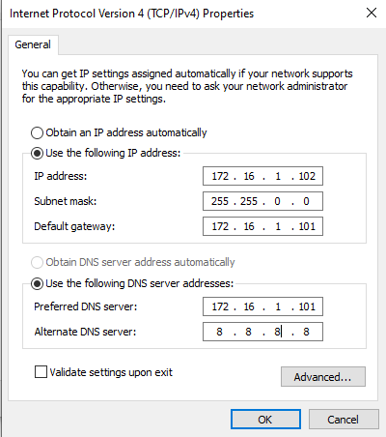

**EXPERIMENT-4**

**Identify the Desktop Virtualization Infrastructure in Lab Configured Workstation.**

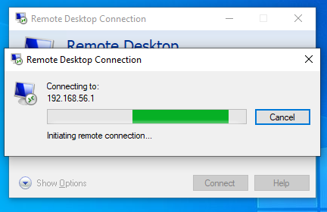

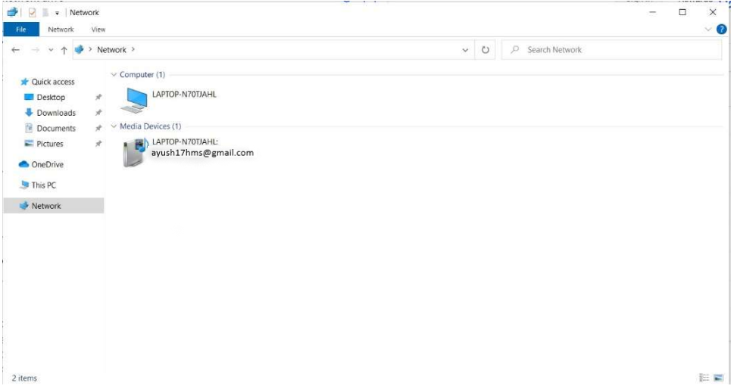

**EXPERIMENT – 5**

1. **Now open oracle virtual box and import the appliance of Zentyal**
2. **After successful import check the IP address of the imported Zentyal machine**
3. **Now access the Zentyal from the web browser throughhttp://ip_address:8443". The default port is 8443.**
4. **Now you will see the web interface of the Zentyal Server on Virtual Machine.**
5. **Now through the Zentyal Web interface check various services provided by Zentyal**

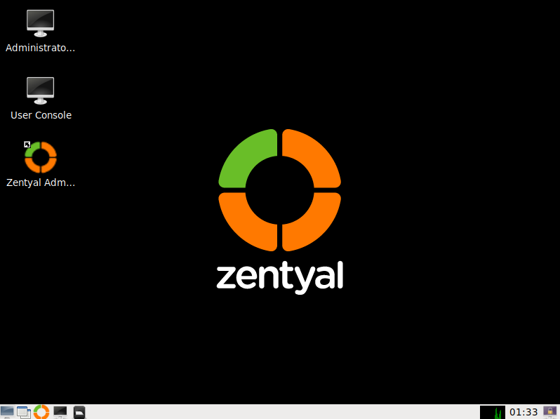

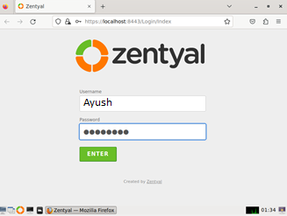

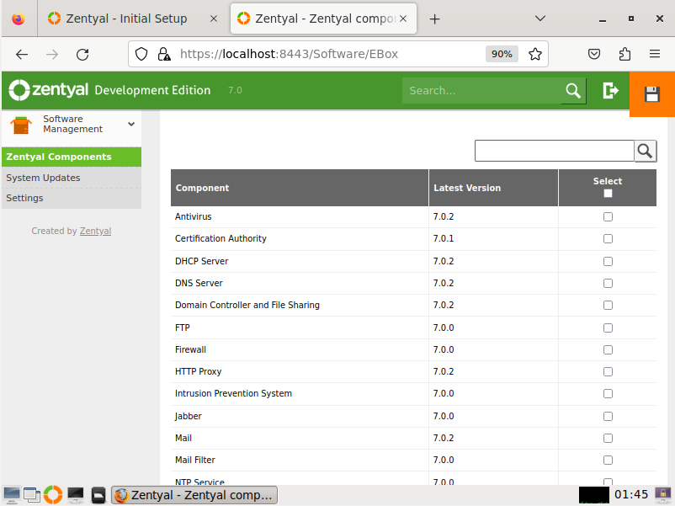

**EXPERIMENT – 6**

1. **Download Oracle Virtual Box**
2. **Install Oracle Virtual Box**
3. **Create a Virtual Machine with maximum available resources of your system**

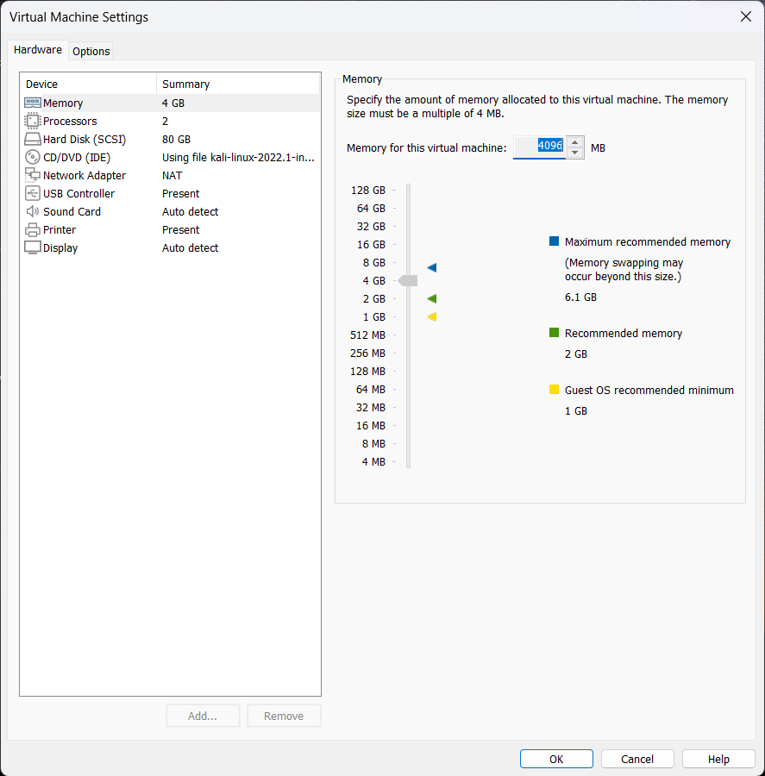

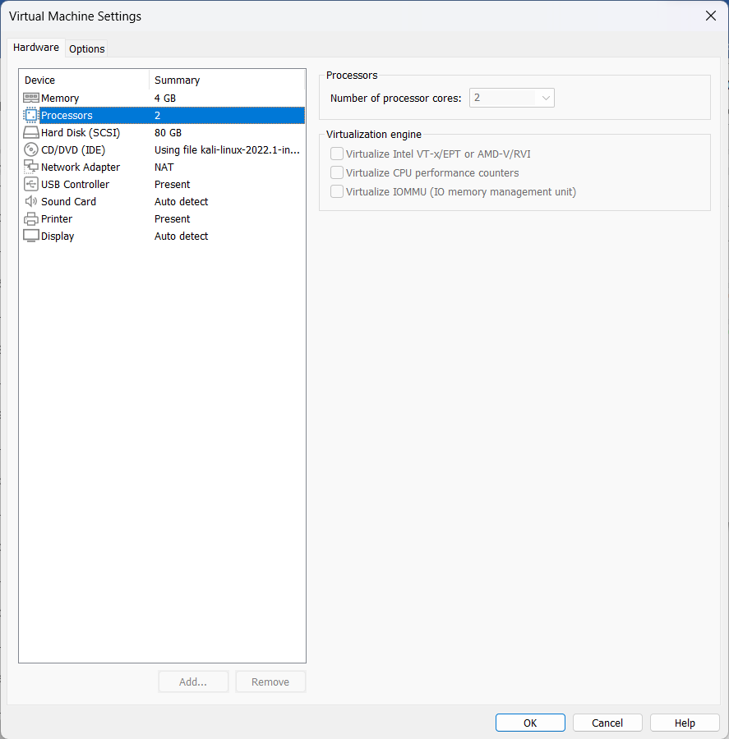

**EXPERIMENT – 7**

**Take a backup of the configured VM as an Oracle Virtual box appliance.**

**Now import on your friend’s workstation.**

**Check for observations. This is the process of backup and recovery. Note down the entire procedure stepwise.**

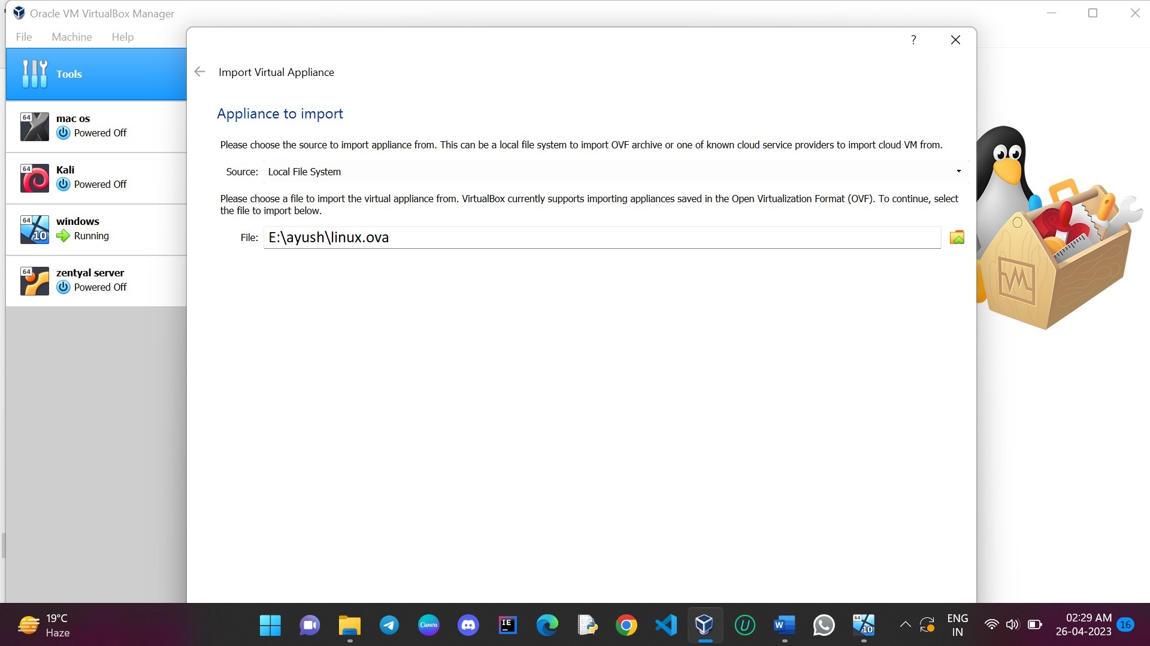

**EXPERIMENT – 8**

**To understand and perform the backup procedure of an entire virtual machine. Student will first create a full function VM in Oracle Virtual Box and then configure it as per his/her requirement.**

**After successful deployment of the VM student will take a backup. Go into file menu→ select Export Appliance → set the name and location of the file. Check the size of the Exported file.**

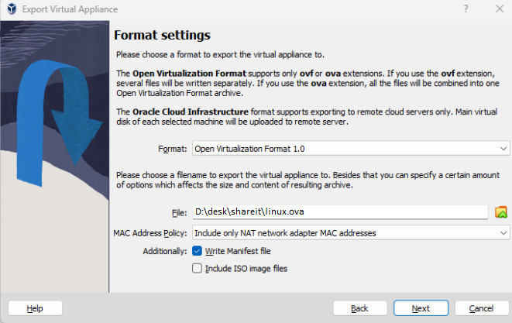

**EXPERIMENT – 9**

**BASIC LINUX COMMANDS**

